Confusion Matrix Case Study
Predictive Brake-Failure Detection for a Commercial Vehicle Fleet
Trainer-ready case study with business context, dataset, model steps, metrics, code, interpretation, and recommendations.
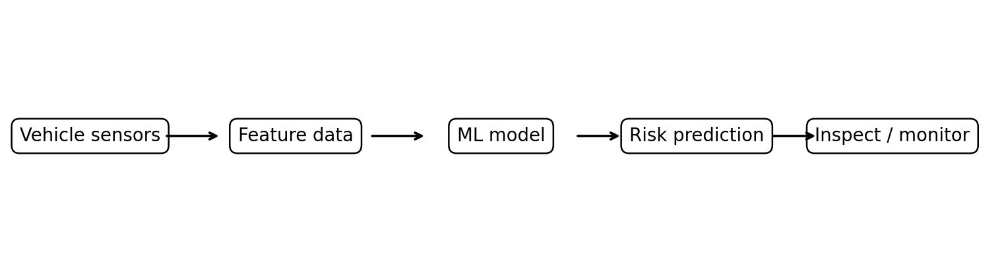
Industry | Automotive / Fleet Maintenance
ML problem | Binary classification
Positive class | Vehicle likely to fail within 30 days
Primary safety metric | Recall for the failure class

Contents
- 1. Executive summary
- 2. 5W1H overview
- 3. Business problem and operating workflow
- 4. Dataset and feature definitions
- 5. Why accuracy fails in an imbalanced dataset
- 6. Confusion matrix and metric calculations
- 7. Step-by-step ML implementation
- 8. Business interpretation and cost analysis
- 9. Recommended production solution
- 10. Trainer discussion questions and exercises
- Appendix A. Complete Python code

1. Executive Summary
A fleet operator wants to predict which vehicles are likely to experience a brake-related failure during the next 30 days. Historical data contains 1,000 vehicles: 950 remain normal and 50 fail. A naive model that predicts every vehicle as normal achieves 95% accuracy, yet misses all 50 risky vehicles. The confusion matrix exposes this dangerous failure by showing 50 false negatives and zero true positives.
The case study demonstrates why the organization must evaluate recall, precision, F1-score, false negative rate, and business cost rather than relying only on accuracy. For safety-sensitive failure prediction, recall for the failure class is normally the primary metric, while precision controls unnecessary inspections.

2. 5W1H Overview
5W1H | Explanation
What? | A binary classification system that predicts Normal or Failure within 30 days.
Why? | To detect risky vehicles before breakdown, injury, towing, service disruption, or costly repair.
Who? | Fleet managers, maintenance engineers, service centres, safety teams, drivers, and data scientists.
Where? | Commercial fleets, connected-car platforms, service workshops, logistics operators, and OEM systems.
When? | The model runs daily or after new sensor/diagnostic data arrives; alerts trigger preventive inspection.
How? | Collect telemetry, engineer features, train a classifier, evaluate with a confusion matrix, tune the threshold, and monitor results.

3. Business Problem and Operating Workflow

3.1 Problem statement
Predict whether each vehicle will experience a brake-related failure in the next 30 days. The prediction must support a maintenance decision: inspect immediately or continue monitoring.

3.2 Business objective
- Reduce unexpected vehicle breakdowns.
- Prevent safety incidents caused by missed brake deterioration.
- Prioritize workshop capacity for the highest-risk vehicles.
- Reduce emergency towing, roadside repair, and delivery disruption.
- Create an auditable reason for each preventive-maintenance alert.

3.3 Operational decision flow
- Collect sensor, diagnostic, mileage, and service-history data.
- Calculate the probability of failure for each vehicle.
- Compare the probability with the chosen decision threshold.
- Flag high-risk vehicles for inspection.
- Record inspection findings and actual failures for future retraining.

4. Dataset and Feature Definitions

4.1 Class distribution
Actual class | Vehicle count | Percentage
Normal | 950 | 95%
Failure within 30 days | 50 | 5%
Total | 1000 | 100%
This is an imbalanced classification problem because the failure class represents only 5% of the data.

4.2 Input features
Column | Meaning | Example
mileage_km | Total distance travelled | 132000
brake_wear_percent | Estimated brake wear | 94%
brake_temperature_c | Recent operating temperature | 145°C
vibration_level | Normalized vibration reading from 0 to 10 | 8.7
days_since_service | Days since the previous service | 610
warning_light_count | Number of recent brake/ABS warnings | 4
failure_next_30_days | Target: 1 = failure, 0 = normal | 1

4.3 Sample records
Vehicle | Mileage | Wear % | Temp °C | Vibration | Days | Warnings | Target
VH-0582 | 125851 | 45.9 | 91.8 | 9.44 | 288 | 1 | 1
VH-0807 | 84010 | 54.5 | 141.9 | 6.65 | 311 | 0 | 1
VH-0445 | 78714 | 92.6 | 55.2 | 6.3 | 503 | 0 | 1
VH-0694 | 142173 | 53.3 | 93.4 | 6.05 | 599 | 0 | 1
VH-0453 | 77378 | 87.9 | 117.3 | 6.61 | 454 | 0 | 1
VH-0936 | 141386 | 99.6 | 66.4 | 4.73 | 375 | 1 | 1
VH-0668 | 129804 | 75.4 | 75.9 | 8.05 | 230 | 0 | 0
VH-0652 | 99625 | 41.3 | 75.5 | 4.6 | 678 | 1 | 0
VH-0653 | 34341 | 82.6 | 93.1 | 3.25 | 310 | 2 | 0
VH-0654 | 121636 | 51.7 | 65.0 | 3.45 | 189 | 1 | 0
VH-0655 | 85190 | 80.8 | 76.2 | 2.25 | 376 | 1 | 0
VH-0656 | 82244 | 56.2 | 91.2 | 7.03 | 108 | 0 | 0
Note: The supplied CSV contains all 1,000 synthetic records. In a real project, the target label must come from confirmed historical failures, workshop inspections, or warranty/service events.

5. Why Accuracy Fails in an Imbalanced Dataset

5.1 Misleading baseline
Assume the model predicts every vehicle as Normal. It correctly classifies all 950 normal vehicles and incorrectly classifies all 50 failure vehicles.
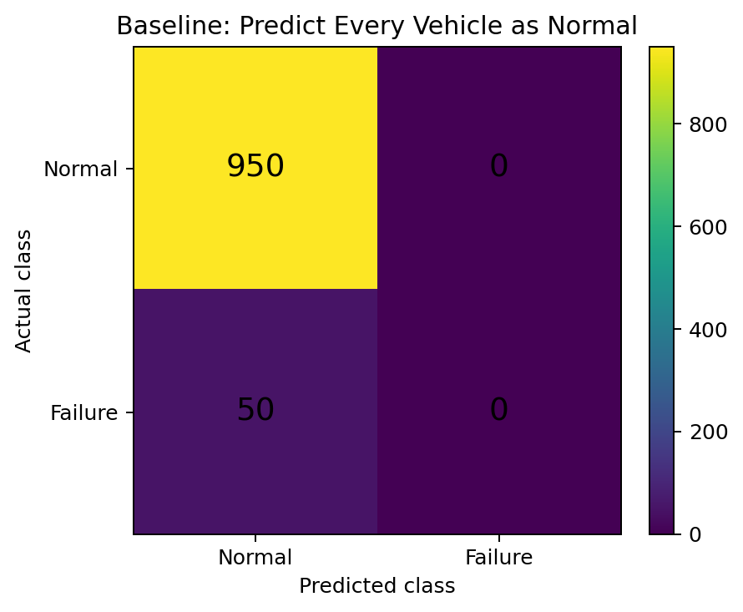
Actual / Predicted | Predicted Normal | Predicted Failure
Actual Normal | 950 (TN) | 0 (FP)
Actual Failure | 50 (FN) | 0 (TP)
Accuracy = (TP + TN) / Total = (0 + 950) / 1000 = 95%
Failure recall = TP / (TP + FN) = 0 / (0 + 50) = 0%
The 95% accuracy is operationally useless because the model identifies none of the vehicles that need preventive maintenance. Every actual failure is a false negative.

5.2 Why false negatives are serious
- A risky vehicle is allowed to continue operating.
- A brake issue may become a safety incident instead of a planned repair.
- Emergency repair and towing are usually more expensive than preventive service.
- Unexpected downtime can delay deliveries and reduce fleet availability.
- The organization may face warranty, legal, regulatory, and reputational consequences.

6. Confusion Matrix and Metric Calculations

6.1 Illustrative trained-model result
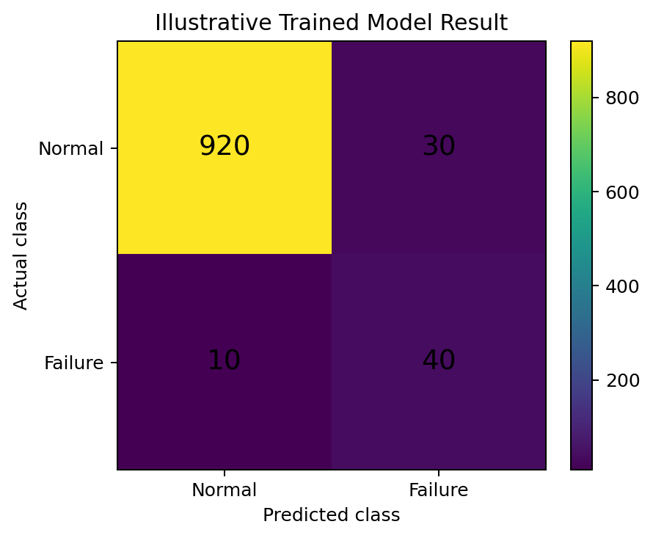
Actual / Predicted | Predicted Normal | Predicted Failure
Actual Normal | 920 = True Negative | 30 = False Positive
Actual Failure | 10 = False Negative | 40 = True Positive
Metric | Formula | Calculation | Result
Accuracy | (TP + TN) / Total | (40 + 920) / 1000 | 96%
Precision | TP / (TP + FP) | 40 / (40 + 30) | 57.14%
Recall | TP / (TP + FN) | 40 / (40 + 10) | 80%
F1-score | 2 × Precision × Recall / (Precision + Recall) | 2 × 0.5714 × 0.8 / (0.5714 + 0.8) | 66.67%
Specificity | TN / (TN + FP) | 920 / (920 + 30) | 96.84%
False negative rate | FN / (FN + TP) | 10 / 50 | 20%

6.2 Interpretation
- The model finds 40 of the 50 risky vehicles.
- It still misses 10 risky vehicles; these are the highest-priority errors to investigate.
- Thirty normal vehicles are inspected unnecessarily.
- The organization must decide whether 80% recall is safe enough or whether the threshold should be lowered.

7. Step-by-Step ML Implementation
Implementation step | Purpose
Step 1 - Define the target | 1 means failure within 30 days; 0 means normal.
Step 2 - Collect historical data | Use sensor readings, diagnostic codes, mileage, service dates, and verified failure outcomes.
Step 3 - Validate data quality | Check missing values, impossible readings, duplicates, label errors, and data leakage.
Step 4 - Split features and target | X contains vehicle attributes; y contains the failure label.
Step 5 - Use a stratified split | Preserve the minority-class proportion in train and test datasets.
Step 6 - Train a class-aware model | Use class_weight="balanced" or another imbalance strategy.
Step 7 - Predict probabilities | Probability enables threshold tuning rather than forcing the default 0.50 threshold.
Step 8 - Build the confusion matrix | Count TN, FP, FN, and TP.
Step 9 - Compare business metrics | Prioritize failure recall and false negatives; use precision to control inspection workload.
Step 10 - Tune and monitor | Choose a threshold based on safety and cost, then monitor drift and retrain.

7.1 Core implementation code
# Separate features and target
X = data[feature_columns]
y = data["failure_next_30_days"]

# Preserve the minority-class ratio
X_train, X_test, y_train, y_test = train_test_split(
X, y, test_size=0.25, random_state=42, stratify=y
)

# Train a class-aware classifier
model = RandomForestClassifier(
n_estimators=300,
max_depth=6,
min_samples_leaf=3,
class_weight="balanced",
random_state=42,
)
model.fit(X_train, y_train)

# Use probabilities to support threshold tuning
failure_probability = model.predict_proba(X_test)[:, 1]
y_pred = (failure_probability >= 0.15).astype(int)

print(confusion_matrix(y_test, y_pred))
print(classification_report(y_test, y_pred, zero_division=0))

7.2 Why use class_weight="balanced"?
The model sees far more normal vehicles than failed vehicles. Balanced class weights increase the training penalty for misclassifying the minority failure class, helping the algorithm pay more attention to rare failures. It does not guarantee good recall; the confusion matrix is still required.

7.3 Why tune the probability threshold?
Threshold choice | Likely effect | Business consequence
Higher threshold | Fewer vehicles predicted as risky | Fewer inspections but more missed failures
Lower threshold | More vehicles predicted as risky | Higher recall but more unnecessary inspections

8. Business Interpretation and Cost Analysis

8.1 Illustrative cost assumptions
Outcome | Example unit cost | Meaning
True Positive | ₹8,000 | Planned inspection and preventive repair
False Positive | ₹2,000 | Inspection finds no urgent issue
False Negative | ₹2,50,000 | Unexpected breakdown, towing, disruption, and possible safety impact
True Negative | ₹0 incremental | Vehicle continues operating normally

8.2 Example cost comparison
Scenario | Confusion matrix result | Cost calculation | Estimated cost
Baseline: all normal | TP=0, FP=0, FN=50, TN=950 | 50 × ₹2,50,000 | ₹1,25,00,000
Illustrative trained model | TP=40, FP=30, FN=10, TN=920 | (40 × ₹8,000) + (30 × ₹2,000) + (10 × ₹2,50,000) | ₹28,80,000
These costs are illustrative, not company-specific. They show why a model with slightly lower overall accuracy can still be financially and operationally superior if it substantially reduces false negatives.

9. Recommended Production Solution
Area | Recommendation
Primary KPI | Set a minimum acceptable recall for failures based on safety policy, such as 90% or higher.
Secondary KPI | Track precision to ensure workshop capacity is not overwhelmed by false positives.
Threshold | Choose the threshold using expected cost, inspection capacity, and safety risk—not accuracy alone.
Escalation tiers | Use High, Medium, and Low risk bands instead of only a binary alert where operations permit.
Human review | Require maintenance review for high-risk alerts and feedback the confirmed outcome into the dataset.
Monitoring | Monitor confusion-matrix counts by vehicle model, region, climate, road type, and time period.
Retraining | Retrain when sensor behavior, vehicle mix, component design, or operating conditions change.
Governance | Document model version, threshold, input data, explanation, and action taken for every alert.

9.1 Final decision rule
Do not approve a vehicle-failure model because its accuracy is high. Approve it only after confirming that its failure recall, false negative count, inspection workload, business cost, and subgroup performance are acceptable for the intended deployment.

10. Trainer Discussion Questions and Exercises
- Why is a false negative more dangerous than a false positive in brake-failure prediction?
- Would the answer change for a marketing-response model? Why?
- Calculate precision, recall, and F1-score for TP=45, FP=55, FN=5, TN=895.
- What happens to recall and precision when the probability threshold is lowered?
- How would you choose a threshold if the workshop can inspect only 80 vehicles per week?
- Which additional features could improve detection: road roughness, rainfall, payload, driver behavior, or component age?
- How would geographic bias affect a model trained mainly on smooth European roads and deployed in India?

10.1 Practical exercise
- Run the supplied Python program at threshold 0.50.
- Record TN, FP, FN, TP, accuracy, precision, recall, and F1-score.
- Repeat for thresholds 0.30, 0.20, 0.15, and 0.10.
- Select the threshold that best balances missed failures and inspection workload.
- Write a one-paragraph recommendation to the fleet maintenance manager.

Conclusion
A confusion matrix is used because it separates correct and incorrect predictions by class. In this vehicle-failure case, accuracy alone hides the most important error: risky vehicles predicted as normal. The confusion matrix makes those false negatives visible, allows recall and precision to be calculated, and connects model performance to safety, cost, and maintenance decisions.

Appendix A. Complete Python Code
The complete runnable script is also supplied as a separate .py file. The code below is included for review and classroom walkthrough.
"""
Vehicle Failure Prediction - Confusion Matrix Case Study
========================================================

Goal:
Predict whether a vehicle will experience a brake-related failure
within the next 30 days.

Class labels:
0 = Normal vehicle
1 = Risky vehicle / likely failure
"""

import numpy as np
import pandas as pd
import matplotlib.pyplot as plt

from sklearn.ensemble import RandomForestClassifier
from sklearn.metrics import (
ConfusionMatrixDisplay,
accuracy_score,
classification_report,
confusion_matrix,
f1_score,
precision_score,
recall_score,
)
from sklearn.model_selection import train_test_split

# -------------------------------------------------------
# STEP 1: Generate a synthetic fleet dataset
# -------------------------------------------------------
RNG = np.random.default_rng(42)
TOTAL_VEHICLES = 1000

data = pd.DataFrame({
"vehicle_id": [f"VH-{i:04d}" for i in range(1, TOTAL_VEHICLES + 1)],
"mileage_km": RNG.integers(5000, 150000, TOTAL_VEHICLES),
"brake_wear_percent": np.clip(
RNG.normal(55, 20, TOTAL_VEHICLES), 0, 100
),
"brake_temperature_c": np.clip(
RNG.normal(85, 25, TOTAL_VEHICLES), 30, 180
),
"vibration_level": np.clip(
RNG.normal(4.5, 2, TOTAL_VEHICLES), 0, 10
),
"days_since_service": RNG.integers(5, 730, TOTAL_VEHICLES),
"warning_light_count": RNG.poisson(0.7, TOTAL_VEHICLES),
})

# A synthetic risk score is used only to create the training label.
# In a real project, the label comes from historical failure records.
risk_score = (
0.000015 * data["mileage_km"]
+ 0.06 * data["brake_wear_percent"]
+ 0.025 * data["brake_temperature_c"]
+ 0.45 * data["vibration_level"]
+ 0.002 * data["days_since_service"]
+ 0.8 * data["warning_light_count"]
+ RNG.normal(0, 1.2, TOTAL_VEHICLES)
)

# Mark the highest-risk 5% as vehicles that fail within 30 days.
failure_cutoff = np.quantile(risk_score, 0.95)
data["failure_next_30_days"] = (risk_score >= failure_cutoff).astype(int)

print("Class distribution:")
print(data["failure_next_30_days"].value_counts().sort_index())
print()

# -------------------------------------------------------
# STEP 2: Evaluate the misleading baseline
# -------------------------------------------------------
y_actual = data["failure_next_30_days"]
y_baseline = np.zeros(TOTAL_VEHICLES, dtype=int)

print("BASELINE: Predict every vehicle as normal")
print("Confusion matrix:")
print(confusion_matrix(y_actual, y_baseline))
print("Accuracy:", accuracy_score(y_actual, y_baseline))
print("Failure recall:", recall_score(y_actual, y_baseline, zero_division=0))
print()

# Baseline result:
# [[950 0]
# [ 50 0]]
# Accuracy = 95%, but recall for failures = 0%.

# -------------------------------------------------------
# STEP 3: Prepare X and y
# -------------------------------------------------------
feature_columns = [
"mileage_km",
"brake_wear_percent",
"brake_temperature_c",
"vibration_level",
"days_since_service",
"warning_light_count",
]

X = data[feature_columns]
y = data["failure_next_30_days"]

X_train, X_test, y_train, y_test = train_test_split(
X,
y,
test_size=0.25,
random_state=42,
stratify=y,
)

# -------------------------------------------------------
# STEP 4: Train a class-aware model
# -------------------------------------------------------
model = RandomForestClassifier(
n_estimators=300,
max_depth=6,
min_samples_leaf=3,
class_weight="balanced",
random_state=42,
)

model.fit(X_train, y_train)

# -------------------------------------------------------
# STEP 5: Evaluate at the default threshold of 0.50
# -------------------------------------------------------
failure_probability = model.predict_proba(X_test)[:, 1]
default_predictions = (failure_probability >= 0.50).astype(int)

def evaluate(name, y_true, y_pred):
"""Print confusion-matrix metrics for a prediction set."""
cm = confusion_matrix(y_true, y_pred)
tn, fp, fn, tp = cm.ravel()

print(name)
print("Confusion matrix:")
print(cm)
print(f"TN={tn}, FP={fp}, FN={fn}, TP={tp}")
print(f"Accuracy : {accuracy_score(y_true, y_pred):.3f}")
print(f"Precision: {precision_score(y_true, y_pred, zero_division=0):.3f}")
print(f"Recall : {recall_score(y_true, y_pred, zero_division=0):.3f}")
print(f"F1-score : {f1_score(y_true, y_pred, zero_division=0):.3f}")
print(classification_report(y_true, y_pred, zero_division=0))
return cm

default_cm = evaluate(
"MODEL AT DEFAULT THRESHOLD 0.50",
y_test,
default_predictions,
)

# -------------------------------------------------------
# STEP 6: Use a safety-oriented threshold
# -------------------------------------------------------
# Lowering the threshold flags more vehicles for inspection.
# This usually increases recall but also increases false positives.
safety_threshold = 0.15
safety_predictions = (failure_probability >= safety_threshold).astype(int)

safety_cm = evaluate(
f"MODEL AT SAFETY THRESHOLD {safety_threshold}",
y_test,
safety_predictions,
)

# -------------------------------------------------------
# STEP 7: Visualize the safety-threshold confusion matrix
# -------------------------------------------------------
display = ConfusionMatrixDisplay(
confusion_matrix=safety_cm,
display_labels=["Normal", "Failure"],
)
display.plot(values_format="d")
plt.title("Vehicle Failure Confusion Matrix")
plt.tight_layout()
plt.show()

# -------------------------------------------------------
# STEP 8: Predict risk for new vehicles
# -------------------------------------------------------
new_vehicles = pd.DataFrame([
{
"mileage_km": 22000,
"brake_wear_percent": 25,
"brake_temperature_c": 65,
"vibration_level": 2.0,
"days_since_service": 60,
"warning_light_count": 0,
},
{
"mileage_km": 132000,
"brake_wear_percent": 94,
"brake_temperature_c": 145,
"vibration_level": 8.7,
"days_since_service": 610,
"warning_light_count": 4,
},
])

new_probabilities = model.predict_proba(new_vehicles)[:, 1]
new_predictions = (new_probabilities >= safety_threshold).astype(int)

for index, (probability, prediction) in enumerate(
zip(new_probabilities, new_predictions), start=1
):
status = "Inspect immediately" if prediction == 1 else "Continue monitoring"
print(
f"New vehicle {index}: failure probability={probability:.3f} -> {status}"
)

